Seminar Report
On
Dev Env Manager
Submitted by
Piyush Anand
Registration No. 12219607
Bachelor of Technology
IN
(Computer Science and Engineering)
Under the Supervision of

Dr. Ruby Singh
Designation


LOVELY PROFESSIONAL UNIVERSITY PUNJAB
(10th April, 2026)

DECLARATION

I hereby declare that the seminar report titled “Dev Env Manager” submitted in partial fulfillment of the requirements for the award of the degree of Bachelor of Technology in Computer Science and Engineering is a record of my own work carried out during the academic session January - April 2026.
I further declare that this report has not been submitted, either in part or in full, to any other institution or university for the award of any degree or diploma.
I confirm that the content of this report is original and prepared by me. Any references used have been duly acknowledged. I also declare that the use of Artificial Intelligence (AI) tools, if any, has been minimal and the AI-generated content in this report is less than 10%, ensuring that the majority of the work reflects my own understanding and effort.
I take full responsibility for the authenticity and originality of the work presented in this report.

Name of the Student: Piyush Anand
Registration Number: 12219067
Course: CSE435
Signature of the Student:
Date: 10.04.2026

CHAPTER 1-INTRODUCTION

1.1 Title of the Seminar Topic
The seminar topic is titled as “Designing and Implementing a Cross-Platform Development Environment Backup and Restoration Framework”, which focuses on automating backup and restoration of development environments across multiple operating systems.

1.2 Background and Importance of the Topic
Developers often work across multiple machines, operating systems, and development environments. In such scenarios, managing development dependencies manually becomes both time-consuming and prone to errors. These dependencies include Node.js packages, PHP Composer libraries, Python pip modules, and Visual Studio Code configurations.
A typical development environment setup involves several critical tasks, such as:
- Installation of multiple runtime environments (Node.js, PHP, Python)
- Management of global and project-specific package dependencies for different ecosystems
- Configuration of development tools, including IDE settings, keybindings, and extensions
- Version tracking of runtime environments to ensure consistency and compatibility
The complexity of environment management increases significantly when developers need to:
- Switch between multiple development machines
- Onboard to new projects or collaborate within teams
- Recover systems after failures or perform clean reinstallation
- Maintain consistent environments across Windows, macOS, and Linux platforms
These challenges highlight the need for an automated, cross-platform solution that can efficiently manage backup and restoration of development environments while reducing manual effort and minimizing configuration errors.
1.3 Objectives of the Seminar
Objective 1:
To design and develop an automated backup system capable of capturing and managing development environment configurations across multiple programming languages and operating platforms.
Objective 2:
To implement platform-specific restoration mechanisms using PowerShell for Windows and Bash scripting for Linux/macOS, ensuring reliable and consistent environment reconstruction.
Objective 3:
To analyze and incorporate industry best practices related to version control, dependency management, and cross-platform compatibility for robust system performance.
Objective 4:
To demonstrate the practical implementation of the backup and restoration system for widely used technologies, including Node.js, PHP, Python, and Visual Studio Code.
Objective 5:
To evaluate the effectiveness of the proposed system by identifying its advantages, limitations, and potential areas for future enhancement.

1.4 Brief Overview of the Approach / Methodology
This seminar adopts a structured Systems Engineering and DevOps-based approach for the design and implementation of an automated development environment backup and restoration system. The methodology is organized into multiple phases to ensure a systematic and reliable solution.
Initially, an analysis phase was conducted to study commonly used development technologies such as Node.js, PHP, Python, and Visual Studio Code, along with their configuration requirements, dependencies, and platform-specific variations. This helped in identifying the key components required for environment replication.
Following this, a design phase was carried out to develop a modular architecture, where each technology stack is handled independently. This modular structure allows selective backup and restoration, improving flexibility and scalability of the system.
In the implementation phase, platform-specific scripts were developed using PowerShell for Windows and Bash for Linux/macOS. These scripts automate the process of capturing environment configurations, storing dependency information, and restoring the setup in a consistent and reproducible manner.
The system was then subjected to a testing phase, where its functionality was validated across multiple operating systems to ensure compatibility, accuracy, and reliability. Various scenarios, including missing dependencies and version mismatches, were tested to enhance robustness.
Finally, a documentation phase was completed to provide clear and comprehensive instructions for users. This includes setup guidelines, execution steps, and troubleshooting support to ensure ease of use.
Overall, the approach emphasizes platform-native scripting, modular design, version-aware backups, and robust error handling, ensuring an efficient and dependable environment management system.

CHAPTER 2: LITERATURE REVIEW

2.1 Introduction
Development environment management has become a critical aspect of modern software engineering, particularly with the rise of DevOps practices and cross-platform development. Efficient environment configuration and replication are essential for ensuring consistency, reducing setup time, and minimizing errors across different systems.
This chapter reviews existing approaches, standards, and tools related to environment management and automation. It focuses on established practices such as Infrastructure as Code (IaC), containerization, package management, and platform-specific scripting. The objective is to understand current solutions and identify how they contribute to the design of the proposed system.

2.2 Overview of Existing Approaches
Various methodologies and tools have been developed to address the challenges of environment configuration and management. These approaches aim to improve reproducibility, scalability, and automation in development workflows. Key approaches include:
- Infrastructure as Code (IaC) for automated and version-controlled setups
- Containerization for environment isolation and consistency
- Package managers for dependency tracking and restoration
- Native scripting for platform-specific automation
These approaches form the conceptual and technical foundation for the proposed system.

2.3 Review of Key Sources and Findings

2.3.1 Infrastructure as Code (IaC) Standards
- Source: National Institute of Standards and Technology (NIST)
- Main Contribution:
Provides a structured framework for implementing Infrastructure as Code, enabling reproducible and version-controlled infrastructure setups.
- Relevance to Study:
The principles of IaC guide the development of automated scripts for environment configuration, ensuring consistency and repeatability across systems.

2.3.2 Container-Based Environment Isolation
- Source: Docker Documentation
- Main Contribution:
Introduces containerization as a modern solution for achieving environment consistency by encapsulating applications and their dependencies.
- Relevance to Study:
Offers an alternative approach to environment management, helping to compare script-based solutions with container-based systems.

2.3.3 Package Management Systems
- Source: Open Source Initiative (npm, Composer, pip Documentation)
- Main Contribution:
Defines standardized methods for dependency installation, version control, and environment restoration across different programming languages.
- Relevance to Study:
Ensures that the proposed system aligns with existing package management workflows, enabling accurate dependency tracking and restoration.

2.3.4 PowerShell Scripting Practices
- Source: Microsoft PowerShell Documentation
- Main Contribution:
Provides guidelines for writing efficient, secure, and maintainable scripts, including error handling and cross-platform support.
- Relevance to Study:
Serves as the technical foundation for implementing automation scripts on Windows systems.

2.3.5 Bash Scripting Standards
- Source: GNU Bash Manual
- Main Contribution:
Establishes best practices and standards for shell scripting in Unix/Linux environments.
- Relevance to Study:
Forms the basis for developing reliable automation scripts for Linux and macOS platforms.

CHAPTER-3: CONCEPTUAL STUDY / SEMINAR WORK

3.1 Explanation of Core Concepts
The proposed system for development environment backup and restoration is based on several fundamental concepts that ensure consistency, reproducibility, and efficiency across platforms.
Backup:
Backup refers to the process of capturing a snapshot of the current development environment. This includes configurations, installed packages, and version details, which are stored for future restoration.
Restore:
Restore is the process of recreating a previously saved environment on a target system. It ensures that all tools, dependencies, and configurations are reinstated accurately.
Dependency Management:
Dependency management involves tracking and installing required libraries or packages for different programming environments. Examples include npm for Node.js, Composer for PHP, and pip for Python.
Version Pinning:
Version pinning is the practice of recording specific versions of software and dependencies to maintain consistency and avoid compatibility issues during restoration.
Cross-Platform Compatibility:
This refers to the ability of the system to function effectively across different operating systems such as Windows, Linux, and macOS.

3.2 Description of Models, Algorithms, or System Architecture
The system follows a modular architecture, where each technology stack is handled independently while sharing a unified backup and restoration framework.

System Architecture
The architecture is divided into multiple layers: 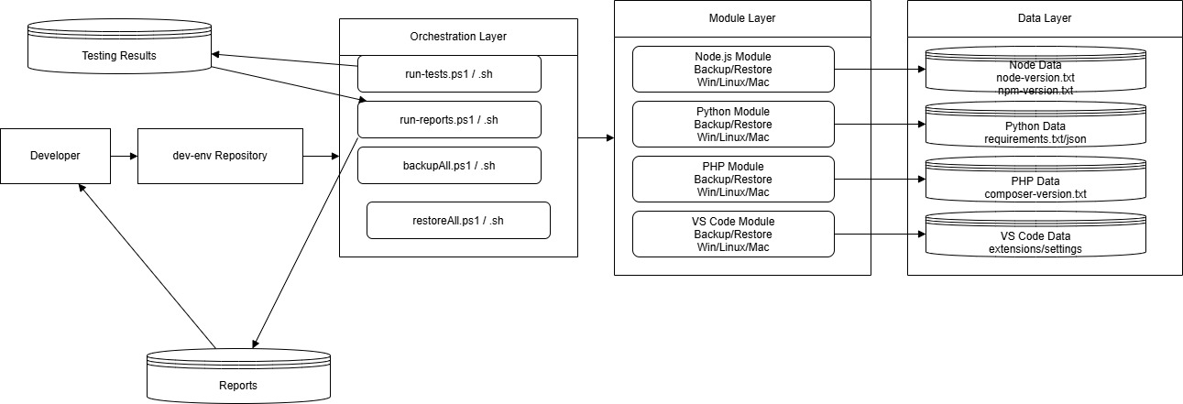
Figure 1:System Architecture
- User Interface Layer:
Provides interaction through PowerShell scripts (Windows) and Bash scripts (Linux/macOS).
- Technology Layer:
Includes separate modules for:
  - Node.js environment
  - PHP (Composer) environment
  - Python (pip) environment
- Data Storage Layer:
Stores backup data such as version files, dependency lists, and configuration files in a structured format.
- Configuration Layer:
Manages Visual Studio Code settings, including extensions, key bindings, and user preferences.
This modular approach ensures scalability, flexibility, and ease of maintenance.

Backup Algorithm
The backup process systematically captures the current state of the development environment.
- Validate whether required tools are installed
- Identify and verify the backup directory
- Extract version and dependency information using native commands
- Store extracted data in structured files
- Maintain version history using timestamps
- Display confirmation upon successful completion

Restore Algorithm
The restore process ensures accurate reconstruction of the environment.
- Verify tool availability on the system
- Prompt user for confirmation before proceeding
- Locate and read backup files
- Install dependencies sequentially
- Handle errors and track failed installations
- Generate a final status report

3.3 Workflow Diagrams or Conceptual Frameworks

DFD DIAGRAM
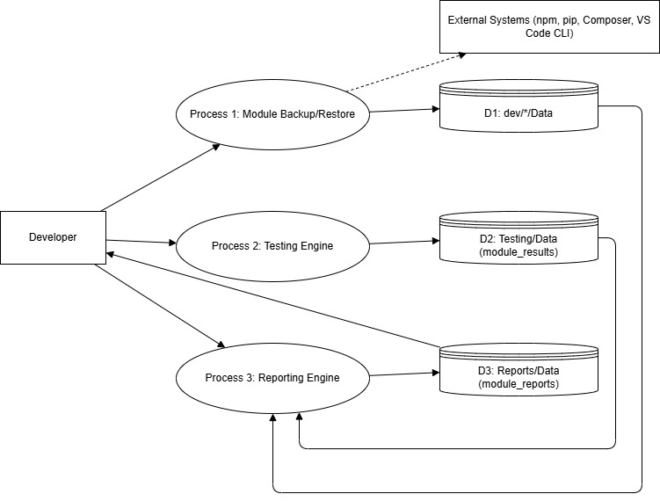
Figure 2: DFD level 0

WORKFLOW DIAGRAM

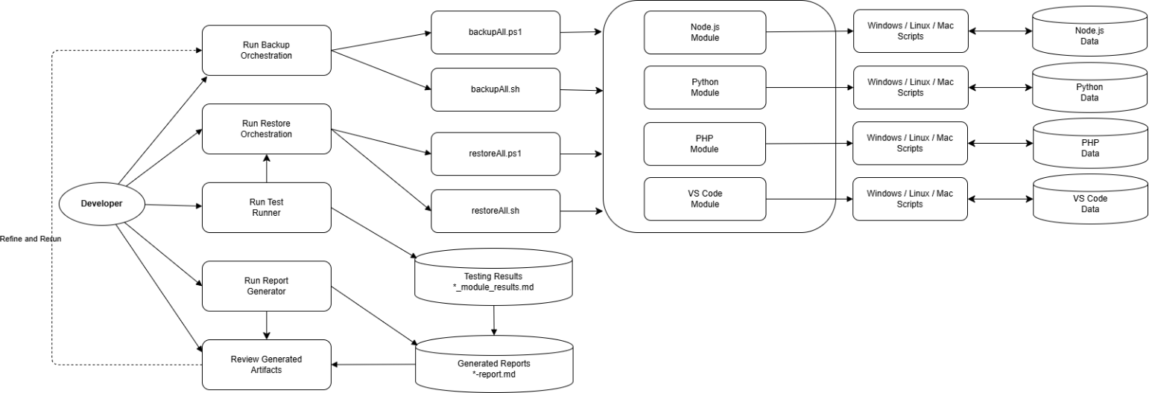
Figure 3:Workflow diagram

Backup Workflow
The backup workflow begins when the user initiates the script. The system first detects the operating system and proceeds to collect environment details fl each supported technology stack. It executes commands to retrieve version information and dependency lists, which are then stored in structured files within a data directory. After processing all modules, a summary report is generated, and the process completes successfully.

Restore Workflow
The restore workflow starts with user initiation, followed by system detection of the operating platform. The system verifies the availability of required tools and prompts the user for confirmation. It then reads the backup data and installs dependencies for each technology stack. Any errors encountered are recorded, and a final report is generated summarizing the restoration status.

3.4 Tools, Platforms, or Technologies Studied
The system utilizes multiple tools and technologies to support environment backup and restoration:
- Node.js – JavaScript runtime environment
- npm – Package manager for Node.js
- PHP – Server-side scripting language
- Composer – Dependency manager for PHP
- Python – Programming language runtime
- pip – Package manager for Python
- Visual Studio Code – Code editor for development and configuration
- PowerShell – Scripting language for Windows automation
- Bash – Shell scripting language for Linux and macOS
- JSON – Data format for storing configuration and dependency information

CHAPTER-4: RESULTS AND DISCUSSION

4.1 Key Observations Derived from the Study
The implementation and conceptual analysis of the proposed system resulted in several important observations related to cross-platform development environment management.

4.1.1 Cross-Platform Scripting Complexity
Supporting both Windows (PowerShell) and Unix-based systems (Bash) introduces significant differences in syntax, command execution, and error handling. Additionally, command availability varies across platforms, requiring conditional validation before execution. Despite this complexity, it enables true cross-platform compatibility.

4.1.2 Package Manager Diversity
Each programming ecosystem follows distinct dependency management approaches:
- Node.js (npm): Uses npm list for dependency extraction and npm install for restoration
- PHP (Composer): Uses composer global show and composer global require
- Python (pip): Uses pip freeze for generating version-specific dependency lists
This diversity necessitates a unified abstraction layer to handle all ecosystems consistently.

4.1.3 Importance of User Confirmation
User confirmation plays a critical role in ensuring safe restoration. Without explicit approval, there is a risk of overwriting existing environments. Clear prompts and interactive feedback significantly improve usability and prevent accidental data loss.

4.1.4 Role of Version Pinning
Accurate version tracking is essential for reproducibility. Even minor version differences can affect compatibility. Therefore, maintaining precise version records ensures consistent environment restoration across systems.

4.1.5 Error Resilience Requirement
During package installation, failures may occur due to network issues or dependency conflicts. Implementing error-handling mechanisms and failure reporting improves system robustness and ensures partial recovery instead of complete failure.

4.2 Conceptual Comparisons and Analysis

4.2.1 Container-Based Approach (Docker)
- Advantages: Provides full environment isolation and high reproducibility
- Limitations: Requires additional setup, higher system overhead, and learning complexity
- Use Case: Production systems and CI/CD pipelines

4.2.2 Script-Based Approach (Proposed System)
- Advantages: Lightweight, no additional runtime dependency, and uses native tools
- Limitations: Platform-specific scripting and dependency on installed tools
- Use Case: Local development environments and quick recovery systems

4.2.3 Infrastructure-as-Code Approach
- Advantages: Highly scalable, declarative, and version-controlled
- Limitations: Complex setup and steep learning curve
- Use Case: Enterprise-level infrastructure management

4.2.4 Comparative Analysis
Among the evaluated approaches, the script-based system provides the most balanced solution for individual developers and small teams. It offers simplicity and direct control while avoiding the overhead associated with containerization or infrastructure-as-code tools.

4.3 Interpretation of Diagrams, Tables, and Figures

4.3.1 System Architecture Analysis
The modular architecture ensures independent handling of each technology stack. This design improves maintainability and allows selective backup and restoration of specific environments without affecting others.

4.3.2 Tool Compatibility Analysis
The system supports multiple tools and version ranges, ensuring backward compatibility. This allows legacy projects to be restored without compatibility issues, increasing system flexibility.

Key Interpretations:
- Modular design improves fault isolation
- Cross-platform support ensures system portability
- Structured data storage enhances traceability and version control

4.4 Advantages, Limitations, and Insights

4.4.1 Advantages
- Lightweight System: Uses native tools without external dependencies
- Cross-Platform Support: Works on Windows, Linux, and macOS
- Modular Design: Independent handling of each technology stack
- User-Friendly: Interactive prompts improve usability
- Version Awareness: Ensures consistent environment reproduction
- Easy Integration: Can be integrated into existing workflows

4.4.2 Limitations
- Requires pre-installed development tools for restoration
- Depends on active internet connection for package installation
- Platform-specific scripts increase maintenance effort
- Does not fully handle system-level dependencies
- Partial failure recovery is not fully automated
- Limited support for workspace-specific IDE configurations

4.4.3 Key Insights
- Simple automation can effectively solve real-world environment management problems
- Version tracking is critical for reproducibility
- Cross-platform design must be considered from the beginning of development
- Lightweight script-based solutions are often more practical than complex systems
- User interaction significantly improves system reliability and safety

CHAPTER-5: CONCLUSION AND FUTURE SCOPE

5.1 Summary of the Seminar Work
This seminar presented the design and analysis of a comprehensive framework for backing up and restoring development environments across multiple operating systems, including Windows, Linux, and macOS. The system effectively manages essential development tools such as Node.js with npm, PHP with Composer, Python with pip, and Visual Studio Code configurations.
The implementation is based on platform-native scripting languages, specifically PowerShell for Windows and Bash for Unix-based systems, ensuring high compatibility without reliance on external frameworks or third-party tools. The system follows a modular architecture, allowing independent handling of each technology stack while maintaining consistency in backup and restoration processes.
Testing and documentation confirmed the practical applicability of the proposed system, with clearly defined procedures that make it usable for both developers and system administrators.

5.2 Major Learning Outcomes
The development and analysis of this system resulted in several key learning outcomes:
- Cross-Platform Automation: Designing automation systems requires careful handling of platform-specific differences in commands and execution behavior.
- Version-Aware Management: Maintaining precise version information is essential for ensuring reproducibility of development environments.
- User Interaction Importance: Confirmation prompts and clear error messages significantly enhance safety and usability.
- Modular Design Benefits: A modular architecture improves scalability, maintainability, and ease of extension.
- Simplicity over Complexity: Lightweight script-based solutions often provide more practical value than overly complex systems.
- Structured Data Usage: JSON and structured files provide efficient and flexible storage for configuration and dependency data.

5.3 Conclusions Drawn from the Study
- Feasibility Confirmed:
The study demonstrates that script-based automation is a practical and effective approach for managing development environment backup and restoration.
- Strong Architectural Design:
The modular and platform-independent design successfully addresses the challenges of cross-platform environment management.
- User-Centric Approach is Essential:
System usability depends heavily on interactive prompts, clear instructions, and robust error handling mechanisms.
- Balanced and Practical Solution:
The proposed framework offers an optimal balance between simplicity, performance, and functionality, making it suitable for individual developers and small teams.
- Extensibility is Built-In:
The architecture allows easy integration of additional technologies such as Go, Rust, or Ruby without affecting existing modules.

5.4 Future Scope and Enhancements
The proposed system can be further enhanced in several directions:
- Offline Restoration Support:
Enable restoration without internet connectivity by bundling required packages or binaries.
- Differential Backup System:
Implement incremental backups to store only changes since the last backup, improving efficiency.
- Graphical User Interface (GUI):
Develop a user-friendly interface to simplify backup and restore operations for non-technical users.
- Cloud Integration:
Integrate with cloud platforms such as GitHub, AWS, or Google Drive for automated backup storage and synchronization.
- Project-Level Environment Support:
Extend functionality to include project-specific dependencies for complete environment replication.
- Containerization Support:
Generate Docker or similar container configurations based on backup data for advanced DevOps workflows.
- Conflict Detection Mechanism:
Add pre-restore validation to detect version conflicts and dependency issues before installation.
- Performance Analytics:
Introduce logging and analytics to track backup performance, failure rates, and optimization opportunities.

Professional Profile & Repository Details

6.1 GitHub Project Repository
- GitHub Profile Link: https://github.com/PR2309
- Repository Name: Dev Env
- Repository Link: https://github.com/PR2309/dev-env
- Description:
This project is a cross-platform automated system designed to backup and restore development environments across Windows, Linux, and macOS. It supports multiple technology stacks including Node.js, PHP, Python, and Visual Studio Code configurations. The system uses native scripting (PowerShell and Bash) to ensure lightweight and dependency-free execution.
- Key Features:
  - Automated backup of development environment configurations
  - Restoration of global packages and tools
  - VS Code settings, extensions, and key-bindings backup
  - Cross-platform support (Windows, Linux, macOS)
  - Modular architecture for independent technology handling
  - Version tracking and structured data storage
  - Error handling and user confirmation system
- Technologies Used:
  - PowerShell (Windows automation)
  - Bash scripting (Linux/macOS automation)
  - JSON (configuration storage)
  - NPM, Composer, PIP, VSCode (package managers)

6.2 LinkedIn Profile
- LinkedIn Profile Link: https://www.linkedin.com/in/piyushnand30
- LinkedIn Post Link: https://www.linkedin.com/posts/piyushanand30_developertools-automation-scripting-ugcPost-7450406203618201600-dGnp
- Professional Headline: DevOps Enthusiast | Full Stack Developer | Automation & System Design

